PAPER TITLE, MAXIMUM 2 ROWS (TITLE TIMES NEW ROMAN 16 POINTS, BOLD, CENTER, ALL CAPS)

George DRAGHICI1 and Alain BERNARD2 (Times New Roman, 12 points, bold, centered)

Author affiliation and contact information (Style Author affiliation, Times New Roman, 10 points, centered, italic)

1 Universitatea Politehnica din Timişoara, Centrul de Cercetare Inginerie Integrată, Mihai Viteazu 1, 300222 Timişoara, România, E-mail: gdraghici@eng.utt.ro

2 École Centrale de Nantes 1, Rue de la Noë, BP 92101 44321-Nantes Cedex 3 France

E-mail:alain.bernard@irccyn.ec-nantes.fr

**ABSTRACT**: The abstract should have a maximum of 10 rows written in English. The page settings and text formatting should respect the requirements outlined in this guide. The paper should have between 6 and 8 pages. The last page should not have more than 10 empty rows. The file containing the paper should be saved with the following name: Your_Full_Name_1.docx. If you have a second paper as first author, the 1 at the end should be replaces with a 2. (Body Text Indent, Times New Roman, 11 points, italic, justify)

**KEYWORDS**: a maximum five keywords that reflect the subject of the paper (Body Text Indent, Times New Roman, 11 points, italic, justify)

# INTRODUCTION (heading 1, TIMES NEW ROMAN 12 POINTS, BOLD, LEFT, ALL CAPS)

The introduction will contain the general aspects of the research, the objectives and the methodology. The text style is Normal, written in Times New Roman font, 11 points, justified and with a 5-mm indentation on the first line.

# CHAPTER TITLE (HEADING 1, TIMES NEW ROMAN 12 POINTS, BOLD, LEFT, ALL CAPS)

The text will be written with the normal style with a 5-mm indent on the first line, single line spacing. The font is Times New Roman, 11 pt. Please do not add empty rows before of after chapter titles, unless required (if the title is at the bottom of the page).

## Sub-chapter title (Heading 2, Times New Roman 12 points, bold, left)

Each chapter can have sub-chapters. This template had five levels of sub-chapters. Please try and limit yourself to these levels.

### Second level sub-chapter (Heading 3, Times New Roman 11 points, italic, left)

Try to structure your paper in such a way as to use the space accordingly.

# PAPER STRUCTURE

## General recommendations

The paper will be write in Microsoft Word (version 2007 or newer) saved with your name as the file name (Your_Name_1.docx).

Please follow the instructions in this template.

## Page settings

The page settings will be:

* Top: 2.5 cm
* Bottom: 2 cm
* Left: 2 cm
* Right: 2 cm
* Header: 1.5 cm
* Footer: 1.5 cm
* (List Continue, Times New Roman, 11 points, normal, justify).

Paper size is 210/297 mm (A4) and paper orientation is portrait.

## The writing in two columns

### Paper text, mathematical formulas, figures and tables (italic, 12 points)

Paper text will be written as follows:

* Number of Columns: 2
* Width and Spacing:
* Col # 1 (2)
* Width: 8.15 cm
* Spacing: 0.7 cm
* Equal Columns Width: √

All line spacing is exact. Never add any space between lines or paragraphs. When a column has blank lines at the bottom of the page, you can balance the columns adding white space above one or more headings in the same page. Optionally, you can add white space above figures, between figures and captions, and below captions.

This is exemplified in this page by adding a 6 pt spacing before a white line located at this column (the line is flagged in red color).

### Tables and mathematical formulas with the width more than one column

In this case it can be introduced in the page an area with a single column between two „section break”. For a matter of text readability, tables and mathe­matical formulas that are larger than one column must be placed at the top or the bottom of the page.

## The text

The text will be elaborate in single format rows; all paragraphs will be in justifying format.

The references will be cited in text like: (Drăghici, 1999), (Bertoluci & Le Coq, 2000).

## The figures, tables and mathematical formulas

### Figures

All the figures will be inserted in text. If in text will be inserted photos, these will be scanned with a resolution of 600 dpi. The maximum width of the figures will be the width of the column. The most appropriate place for placing figures is at the top or the bottom of the page. Avoid inserting small amounts of text between figures, as readers might not notice the text. If there are figures that exceed the column width they will be inserted between two „section break”, the writing style being the same as previous. Placing figures at the top or bottom of the page is mandatory when the width of the figure is larger than the column width. This significantly increases the text readability.

All figures will be labeled with numbers in order of their apparition, according with the following example:

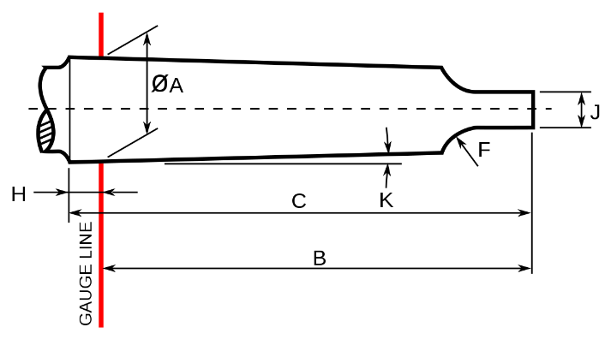

Fig. 1 Example figure

### Tables

Locate tables close to the first reference to them in the text. All tables will be labeled with Arabic numbers like in the model.

Table 1. Model

|  |  |  |  |
| --- | --- | --- | --- |
| **Characteristics/ Measurements** | **Det. No. 1** | **Det.**  **No. 2** | **Det.**  **No. 3** |
| Characteristic A | 12 | 12 | 500 |
| Characteristic B | 150 | 13 | 400 |

All the table lines will have the same width (1 point). The text and the figures will be written with Times New Roman, 10 points, normal (the head of the table must be bold). Explanations should be given at the foot of the table, not within the table itself. Do not place figures or tables sideways on a column; however if this cannot be avoided, no other text but the caption should appear near.

### Mathematical formulas

All mathematical formulas will be written with the equation editor:

$$v=\frac{πdn}{1000} (1)$$

For simple equations in the text always use superscript and subscript (select Font in the Format menu). Do not use the equation editor in text on same line.

# CONCLUding remarks

In this part will be emphasize the contributions of the paper and the future applications in the research field.

# Acknowledgements

Any acknowledgements would be written in this section.

# REFERENCES

Drăghici, G. (1999). *Ingineria integrată a produselor*. Editura Eurobit, ISBN 973-96065-7-1, Timişoara

Moser, H. C. (2004). Trends in EDM, available at: http://www.mmsonline.com/articles/020001.html Accessed: 2004-09-02.

# notation

The following symbols are used in this paper:

Acc = area of core concrete;

At = total area